A Mini Project Synopsis on
E-CANTEEN: FOR APSIT CAMPUS

S.E. – Data Science Engineering

Submitted By
Avadhoot Virkar 22107064
Atharva Thube 22107062
Akash Vidwan 22107007

Under The Guidance Of
Prof. Sheetal Jadhav



DEPARTMENT OF CSE (DATA SCIENCE)
A.P.SHAH INSTITUTE OF TECHNOLOGY
G.B. Road, Kasarvadavali, Thane (W), Mumbai-400615
UNIVERSITY OF MUMBAI

Academic Year : 2023-24

CERTIFICATE

This to certify that the Mini Project report of E-CANTEEN: FOR APSIT CAMPUS has been submitted by Avadhoot Virkar (22107064), Atharva Thube (22107062) and Akash Vidwan(22107007) who are a Bonafide students of A. P. Shah Institute of Technology, Thane, Mumbai, as a partial fulfilment of the requirement for the degree in CSE(DATA SCIENCE), during the academic year 2023-2024 in the satisfactory manner as per the curriculum laid down by University of Mumbai.

Ptof. Sheetal Jadhav
Guide

Prof. Anagha Aher Dr. Uttam D.Kolekar
Head Department of (Data Science) Principal

External Examiner(s)
1.
2.

Place:A.P.Shah Institute of Technology, Thane
Date:

TABLE OF CONTENTS

- Introduction............................................................................................................ 1
  - Purpose.......................................................................................................... 1
  - Objectives...................................................................................................... 2
  - Scope............................................................................................................. 3
- Problem Definition…………………..................................................................... 6
- Proposed System………........................................................................................ 8
  - Features and Functionalities………………………………………………
- Project Outcomes.................................................................................................. 16
- Software Requirements ........................................................................................ 18
- Project Design........................................................................................................19
- Project Scheduling..................................................................................................
- Conclusion..............................................................................................................

References
Acknowledgement

Chapter 1

Introduction
In the digital age, the integration of technology into various aspects of our daily lives has become increasingly prevalent. One such area witnessing transformation is the traditional college canteen, where technology is revolutionizing the dining experience. In the ever-evolving landscape of college life, the traditional campus canteen has emerged as a focal point for student’s social interactions, nourishment and respite. However, the conventional college dining experience often grapples with numerous challenges, ranging from long queues and limited menu options to inefficiencies in service and payment processes. To address these issues and usher in a new era of campus dining, we introduce the "E-Canteen for APSIT Campus" project. This report explores the concept of an 'e-canteen' within a college campus, a cutting-edge solution that leverages technology to enhance convenience, efficiency, and overall satisfaction for students and staff. By delving into the potential benefits, challenges, and implementation strategies, this report aims to shed light on the future of campus dining.
.

  - Purpose:
The purpose of the e-canteen project is to create an efficient and convenient online platform for food ordering and management, primarily targeting college campuses, corporate offices, or similar environments where there is a centralized canteen or cafeteria. In brief, the key purposes of the e-canteen project are:
1. Convenience: To provide a convenient and user-friendly way for customers to order food from the canteen without the need to physically visit the counter.
2. Efficiency: To streamline canteen operations by digitizing the ordering and payment processes.
3. Menu Management: To simplify menu management for canteen operators, allowing them to easily update menus, add new items, and display availability.
4. Payment Option: To offer secure online payment options to the customers.
In summary, the e-canteen project aims to modernize and digitize the food ordering experience, making it more convenient for customers and more efficient for canteen operators.

  - Objectives:
In brief, the objectives of an e-canteen system are to:
1. Enhance Convenience: Simplify the food ordering process and reduce waiting times, allowing customers to order from anywhere.
2. Improve Efficiency: Streamline canteen operations by digitizing order management and inventory tracking, leading to resource optimization.
3. Ensure Menu Accessibility: Make menus easily accessible and informative for all users.
4. Increase Order Accuracy: Reduce errors in orders by providing a clear platform for order customization.
5. Offer Payment Flexibility: Provide various secure payment options to cater to diverse customer preferences.
6. Enhance Customer Satisfaction: Ultimately, the primary goal is to provide a more convenient, efficient, and satisfying food ordering experience for customers and canteen operators.

  - Scope:
The scope of an e-canteen system is extensive, as it encompasses various aspects of food ordering and management in different settings. Here's a detailed exploration of the scope of an e-canteen system:
1. User Interfaces: Development of user-friendly web and mobile interfaces for customers to access the e-canteen system. Creation of a separate interface for canteen operators to manage orders, menus, and inventory.
2. User Registration and Management: Implementation of user registration and login functionalities for customers and canteen staff. User profile management, including personal details and order history.
3. Menu Management: Digitization of menus, including text descriptions, images, and prices. Capability to categorize menu items. Real-time updates of menu availability.
4. Ordering Process: User-friendly interfaces for browsing menus, selecting items, and customizing orders. Integration of secure payment gateways to process online payments. Order confirmation and knowing the waiting time feature for customers.

Chapter 2

Problem Definition
The traditional campus dining experience faces a multiple challenges that hinder its ability to meet the evolving needs and expectations of students and staff. These challenges constitute the core problem that the E-Canteen project seeks to address. The problem can be defined as follows:
Problem Statement:
To design a system to address the challenges faced by traditional canteens in efficiently managing their operations and providing an enhanced user experience to customers. The primary problems to be addressed by this project are as follows:
1. Inefficient Manual Operations: Traditional canteens often rely on manual processes for order taking, payment processing, and inventory management. These manual operations can be error-prone, time-consuming, and lead to inefficiencies in service.
2. Order Tracking and Status: Customers often have no visibility into the status of their orders. This lack of transparency can lead to dissatisfaction and complaints.
3. Payment Processing: Traditional cash-based payment systems can be cumbersome for both customers and canteen staff.
4. Long Queues and Wait Times: Students and staff often endure long queues during peak dining hours, resulting in frustration, wasted time, and a less-than-optimal dining experience.
In summary, the problem definition for the E-Canteen project revolves around the need to transform an outdated and inefficient campus dining system into a modern, customer centric, and sustainable dining experience that enhances customer satisfaction, reduces waiting times, and aligns with contemporary trends in food service.

Chapter 3

Proposed System
Designing an e-canteen system for a college campus involves creating a digital platform that enables students and faculty to order food online, make payments, and have the food delivered to their location or available for pick-up. Here's a proposed system outline for your e-canteen project:
1. User Modules:
a. Student/Faculty Registration:
- Users can create accounts with their college ID.
- Verify accounts admin.
b. Menu Viewing:
- Display categorized menu (breakfast, lunch, snacks, beverages, etc.).
- Include images, descriptions, and prices for each item.
c. Order Placement:
- Users can add items that are to be ordered.
- Specify quantity.
d. Payment Methods:
- Payment through dummy payment system.
e. Order Tracking:
- Real-time tracking of orders.
- Notifications for order confirmation.

2. Admin Modules:
a. Menu Management:
- Add, update, or remove items.
- Set prices, descriptions.
b. Order Management:
- View, process, and track orders.
- Generate order reports for analysis.
c. User Management:
- Manage user accounts.
- Reset passwords and resolve account-related issues.
3. Technology Stack:
- Frontend: Java Language
- Backend: Node.js, Django, and Ruby on Rails (Used: MySQL connector).
- Database: MySQL, PostgreSQL, MongoDB (Used: MySQL).
- Security: private password for users/admin & verification.

Remember, the success of e-canteen system will depend on its usability, reliability, and the quality of service provided. Regularly update the system based on user feedback and technological advancements to ensure its efficiency and relevance.

3.1. Features and Functionality
1. User Registration and Authentication: Users can create accounts by providing their personal information, including name, contact details, and dietary preferences. Secure authentication methods, such as email verification and password reset options, are implemented.
2. User Interfaces: Provide intuitive and user-friendly interfaces for customers to access the system. Separate interfaces for canteen operators and staff to manage orders, menus, and inventory.
3. Menu Management: A comprehensive digital menu is available to users, featuring detailed, high-quality images, and pricing information.
4. Ordering Process: Customers can easily browse menus, select items, and customize their orders. Multiple payment options are integrated, such as online payments and also cash. Users receive order confirmations and real-time order tracking, including estimated delivery or pickup times.
5. Canteen Operations: Canteen operators have access to an order management dashboard, allowing them to view, accept, prepare, and manage incoming orders. Helps in inventory management i.e in stocking various item required for canteen.
This proposed e-canteen system aims to provide a holistic and feature-rich solution, benefiting both customers and canteen operators by enhancing the food ordering and dining experience while optimizing operations and resource management.

Chapter 4

Project Outcome
The project outcome for an e-canteen system can be summarized in terms of its key deliverables, goals, and expected results. Here's a description of the project outcome for an e-canteen system:
Outcome:
The primary goal of the e-canteen project is to create a robust and user-friendly online food ordering and management system that enhances the overall food ordering experience for customers and improves operational efficiency for canteen operators. The project's outcome can be described as follows:
- Time Management: It reduces the waiting time time of the students/faculty. It saves the time of the customers of standing in a long queues and waiting for the order to be ready.
- Improved Customer Experience: Customers benefit from a convenient and efficient food ordering process that eliminates long queues and reduces waiting times. User-friendly interfaces provide a seamless experience for browsing menus, customizing orders, and tracking order status in real-time.
- Enhanced Operational Efficiency: Canteen operators experience improved operational efficiency through automated order processing, inventory management, and streamlined workflows. Data analytics and insights inform menu adjustments, pricing strategies, and targeted marketing efforts, leading to better resource allocation and cost management.
- Scalability and Adaptability: The e-canteen system is designed with scalability in mind, allowing it to accommodate growing numbers of customers. Load balancing and resource optimization ensure smooth operations, even during peak hours.
- Cost Savings: Reduced manual order processing, efficient inventory management, and optimized resource allocation contribute to potential cost savings for canteen operators.
The project's outcome aims to create a win-win situation, benefiting both customers and canteen operators. Customers enjoy a more convenient and satisfying food ordering experience, while canteen operators gain operational efficiency, cost savings, and access to valuable data insights to continually enhance their services.

Chapter 5

Software Requirements
To develop the E-Canteen Management project using MySQL with Java, you will need various software tools and technologies. Here is a list of essential software requirements:

1. Net Beans Apache 18
2. MYSQL (Database)
3. JAVA (backend & frontend)
4. Java Development Kit 21

By ensuring that your system meets these software requirements, you can create, develop, and deploy Java-based applications with a graphical user interface using NetBeans Apache 19, a MySQL database, and Java for both frontend and backend development.

Chapter 6

Project Design
Designing an E-Canteen project involves careful planning and execution to create a user-friendly and efficient system. Here is a high-level outline for the project design:
1. Users :
- Identify user roles such as students and admin.

2. System Architecture :
- Choose appropriate technologies and frameworks for development of project.

3. Graphical User Interface Design :
- Create an responsive & efficient graphical user interface (GUI).
- Design clear and visually appealing menus easy for users to quickly browse available food items.

4. Database Design :
- Design a database to store information about users, canteens, food items, orders, and transactions.
- Implement normalized database tables.

5. Ordering System :
- Develop a user-friendly order placement system that allows users to add items, modify quantities, and remove items if needed.
- Implement a easy payment process for processing payments.

6. User Authentication :
- Implement a secure login system, including features like password & unique username & personal user account.

7. Order Tracking :
- Provide users with the ability to track the status of their orders in real-time.
- Implement a feature for admin to view their ongoing order, including details of past transactions.

8. Admin Dashboard :
- Develop an admin dashboard with functionalities to manage canteens, food items, user accounts, and order records.

By following these steps and incorporating user feedback throughout the development process, the E-Canteen project can deliver a reliable, user-friendly, and efficient online food ordering system.

Block Diagram

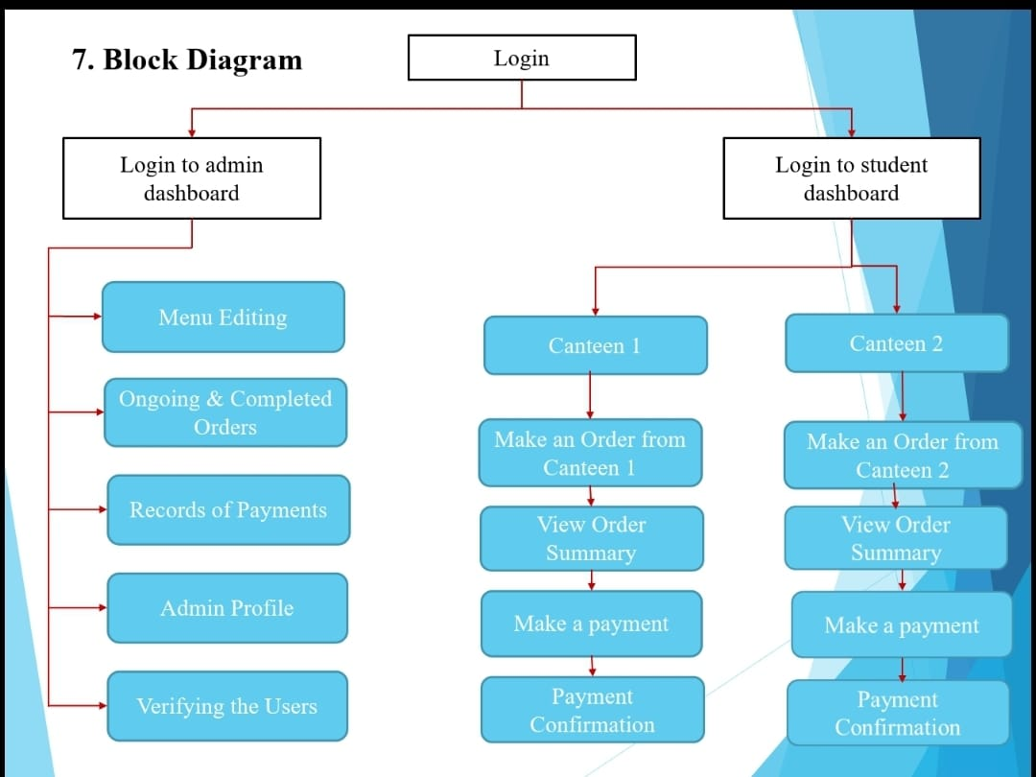

Fig 6.1: Block Diagram
The presented block diagram provides a structured depiction of the project's workflow, explaining every step with precision. Within this visual representation, the project's details are methodically outlined, offering a comprehensive overview of the entire process. Each component and phase of the project is thoughtfully arranged, ensuring a clear and logical flow of information. The diagram not only simplifies the complexity of the project but also conveys crucial information in a visually engaging format. By presenting the project information in this graphical form, it becomes accessible and understandable to various stakeholders, fostering effective communication and collaboration. This well-designed block diagram stands as a valuable tool, serving as a guide for project teams and stakeholders alike, enabling them to navigate the project's intricacies with clarity and confidence.

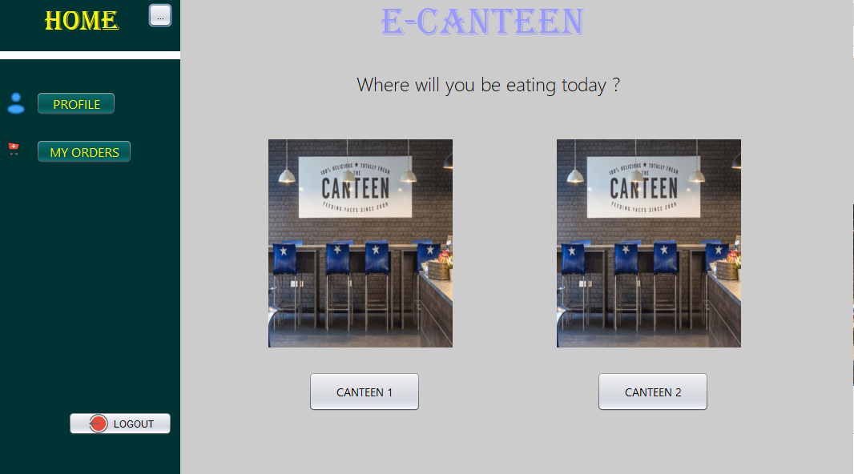

Figure. 6.2: Student Dashboard

The E-Canteen project offers online ordering experience and easy payment options. Within the student dashboard, users can conveniently place orders from two available canteens. This user-friendly interface allows students to select their preferred items and make payments easily. Additionally, the dashboard provides a feature to view order records, enhancing user convenience and ensuring a smooth and efficient ordering process.

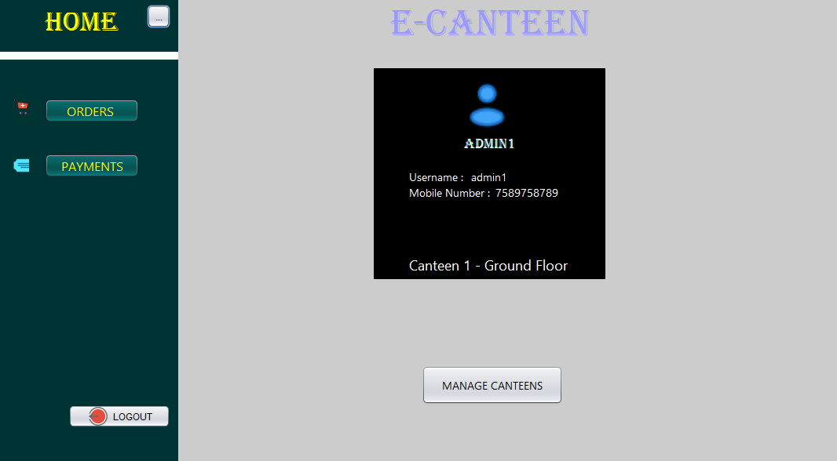

Figure 6.3: Admin Dashboard

In this system, access to the dashboard is restricted to admins only with correct admin credentials stored in the database. Within the dashboard, admin can monitor ongoing and completed orders, review payment records, and utilize an edit menu option for necessary modifications. This setup ensures a secure and efficient management of orders and payments

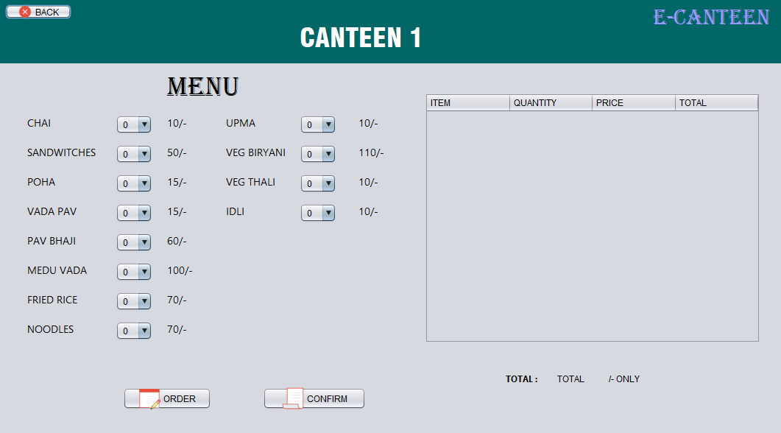

Fig 6.4: Menu For User

The graphical user interface (GUI) of the student order page facilitates a efficient ordering process. Students can effortlessly select desired items and specify quantities. Upon clicking the order button, the system calculates the total amount and estimated waiting time for the order. Users are presented with this information, enabling them to review their choices. Once confirmed, the order is processed, ensuring a convenient and transparent ordering experience for students, enhancing efficiency and user satisfaction.

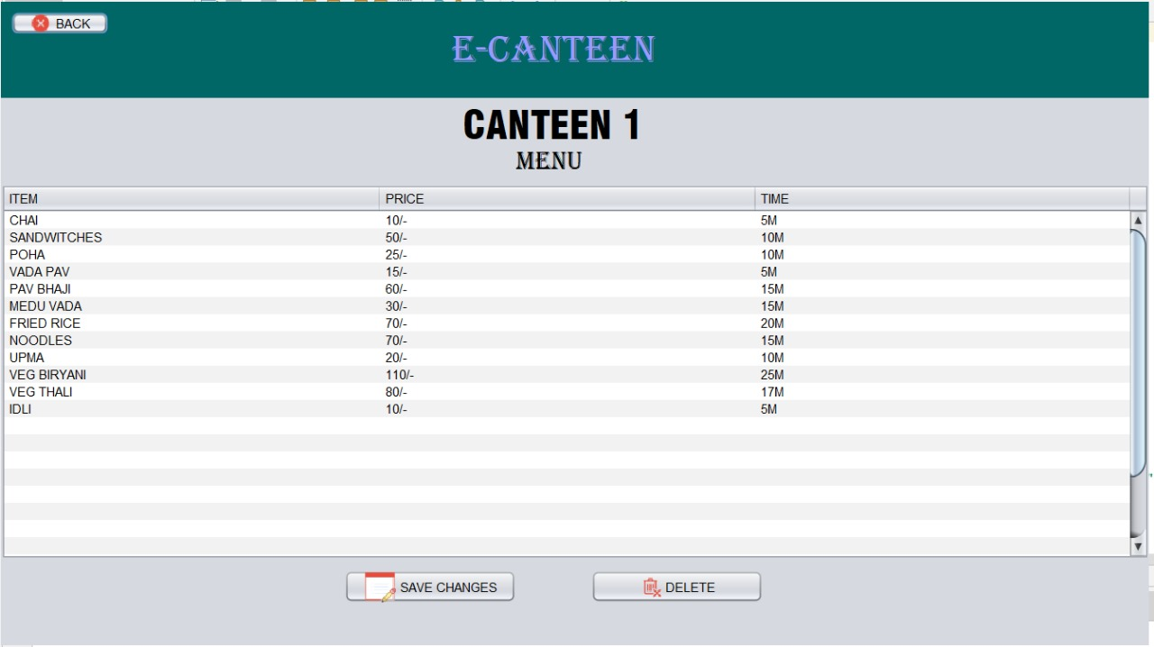

Fig 6.4: Edit Menu For Admin

In the admin edit page, admin have full control over the menu management. They can edit existing menu items, adjusting prices and preparation times as needed. Additionally, admin can add new items or remove existing ones from the menu list, ensuring the menu remains up-to-date and reflective of the available offerings. This feature grants admin flexibility and efficiency in menu customization.

Chapter 7
Project Scheduling
Project Scheduling Template
Sr. No | Group Member | Time duration | Work to be done
1 | Avadhoot Virkar  Atharva Thube  Akash Vidwan | 1st week of August | Implementing “Topic selection and paper visualization"  • Choosing an appropriate topic for the project taking into consideration its relevance, feasibility, and uses.  • Creating a visual representation of the project topic.
 |  | 2nd week of August | Testing “Topic selection and paper visualization"  • Making a paper prototype, along with mapping out its flow, provide a clear framework for the project's design and functionality.
2 | Avadhoot Virkar  Atharva Thube  Akash Vidwan | 3rd week of August | Implementing “Frontend”  • Translating the paper prototype into practical implementation, we adeptly crafted the project's Graphical User Interfaces using NetBeans, leveraging the power of Java programming. With meticulous attention to detail, we seamlessly established connections between the various JFrames and jbuttons, ensuring a cohesive and responsive user experience
3 | Avadhoot Virkar  Atharva Thube  Akash Vidwan | By the end of October month | Implementing “Backend”  • Integrating the GUI components seamlessly in a logical sequence, we established connections between them, ensuring a smooth transition from one interface to another. Simultaneously, we designed and implemented a robust MySQL database, utilizing MySQL Connector, meticulously organizing project data. The result was a cohesive and streamlined flow, enhancing the project's functionality and user experience.
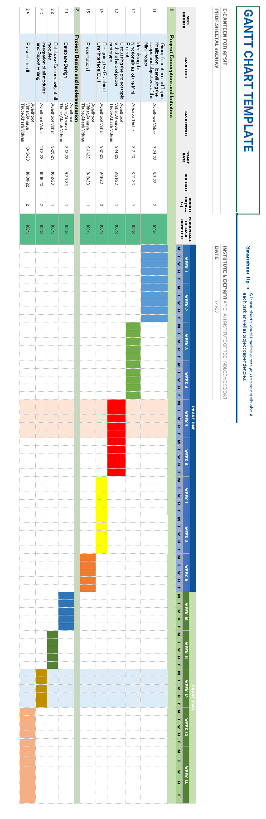

Fig 7.1: Gantt Chart
GANTT CHART

A Gantt chart is a visual representation of a project schedule or plan that shows tasks or activities along a timeline. It is a widely used project management tool that provides a clear and concise way to view the sequence of work and the duration of each task within a project. Gantt charts were developed by Henry L. Gantt in the 1910s and have since become a staple in project management.
Key features of a Gantt chart include:
- Timeline: The horizontal axis represents time, often displayed in days, weeks, or months. It provides a chronological view of the project's schedule.
- Tasks or Activities: Tasks or activities to be completed in the project are represented as horizontal bars on the chart. Each bar corresponds to a specific task or activity and shows its start and end dates.
- Task Duration: The length of each bar represents the duration of the corresponding task. The starting point of the bar marks the task's start date, and the ending point indicates when it is scheduled to be completed.
- Dependencies: Gantt charts can show task dependencies, indicating which tasks must be finished before others can start. These dependencies are often depicted as arrows or lines connecting the bars of dependent tasks.
- Milestones: Milestones are significant events or key points in the project. They are marked on the chart to denote the completion of a critical phase or the achievement of specific goals.
- Resource Allocation: Some Gantt charts include information about resource allocation, indicating which individuals or teams are responsible for each task or activity.
- Progress Tracking: Gantt charts are dynamic tools that allow for tracking progress. As tasks are completed, bars may be shaded or marked to reflect the actual progress made.
Gantt charts are valuable for project planning, scheduling, and monitoring. They help project managers and teams visualize the project's timeline, allocate resources efficiently, identify potential delays, and track progress. They are used in a wide range of industries, including construction, software development, event planning, manufacturing, and more.

Chapter 8
Conclusion
In conclusion, the E-Canteen Management System project represents a significant leap forward in modernizing and optimizing canteen operations. Through the integration of MySQL with Java, we have successfully developed a robust and user-friendly solution that addresses the key challenges faced by traditional canteens.
Throughout the development process, we have accomplished several critical objectives:
1. Efficiency Enhancement
2. Enhanced Accessibility
3. Order Tracking
In conclusion, the E-Canteen Management System project not only modernizes traditional canteen operations but also elevates the overall customer experience. It streamlines processes, improves efficiency, and empowers canteen administrators with valuable insights. As we move forward, there is potential for further enhancements, integration with emerging technologies, and scalability to cater to larger operations. This project stands as a testament to the transformative power of technology in the food service industry, offering a model for canteens looking to thrive in the digital age.

References

Deitel, P. J., & Deitel, H. M. (2015). Java: How to Program (Early Objects). Pearson.
- Oracle Corporation. Java SE Downloads. Retrieved from https://www.oracle.com/java/technologies/javase-downloads.html
- The Apache Software Foundation. Apache NetBeans. Retrieved from https://netbeans.apache.org/
- MySQL. MySQL Database Server. Retrieved from https://www.mysql.com/
- W3Schools. JAVA Tutorial. Retrieved from https://www.w3schools.com/java/
- GitHub. GitHub. Retrieved from https://github.com/
- Jet Brains. IntelliJ IDEA. Retrieved from https://www.jetbrains.com/idea/
- NetBeans. Apache NetBeans. Retrieved from https://netbeans.apache.org/
- Slide shares. Retrieved from https://www.slideshare.net/
- Wikipedia. Retrieved from https://en.wikipedia.org/wiki/
- Java Tutorial. Retrieved from https://www.javatpoint.com/java-tutorial
- Geeks for geeks. Retrieved from https://www.geeksforgeeks.org/java/
- Java tutorial. Net Beans. Retrieved from https://netbeans.apache.org/kb/docs/java/quickstart.html
- YouTube. Retrieved from https://www.youtube.com/watch?v=SfSR4E7PZ-U

ACKNOWLEDGEMENT

This project would not have come to fruition without the invaluable help of our guide Prof. Sheetal Jadhav. Expressing gratitude towards our HoD, Prof.Anagha Aher, and the Department of Data Science for providing us with the opportunity as well as the support required to pursue this project. We would also like to thank our teacher Ms. Poonam Pangarkar who gave us her valuable suggestions and ideas when we were in need of them. We would also like to thank our peers for their helpful suggestions.

